**Level types**: Different types of levels (environment) each with unique challenges to overcome.

***Level 1 setting (tutorial levels [1-3], 10 sub levels)***

Desktop: A stage on a computer screen. Virus protection icons, and other icons on the desktop, could come to life and attack player’s virus.

* Unique Challenges: Multiple “windows” to infect to get to the end of stage. Increasing difficulty with each window
* Perspective: P vs Z right to left.

*Windows desktop with each sub level opening its own window. Background will change as level progresses showing the virus infection*

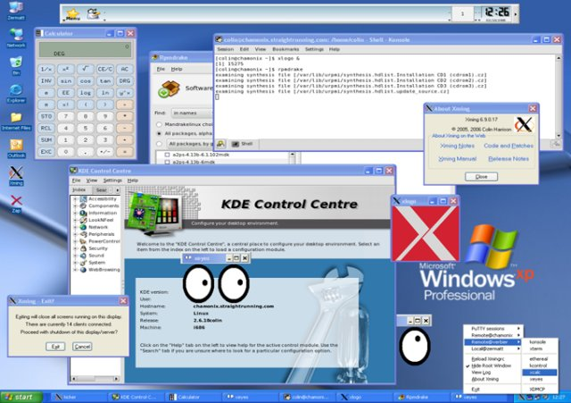

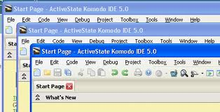

***Level 2 setting (10 sub levels)***

Safe-mode

* looks: Low Rez level (all NPC art is low rez, virus’s will remain normal quality)
* Unique challenge: Have to break through safety barriers to unlock more powerful virus types (you have to earn access to your stronger virus types by defeating sublevels that are designed to counter specific virus types). Defenses also get increasingly harder to get past.
* Perspective: P vs Z right to left.

*Same desktop from first level, but will be in “safe mode”. Last sub level will slowly turn the game board into blue screen of death.*

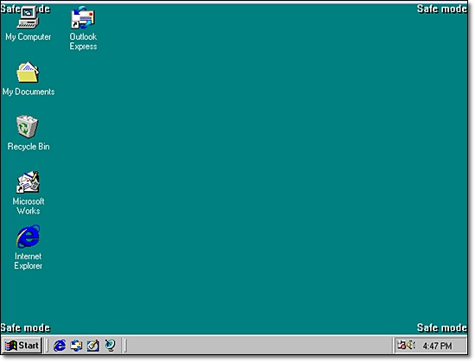

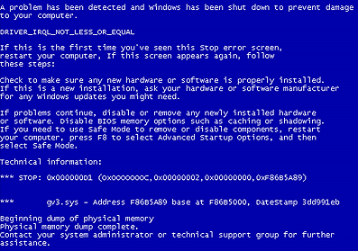

***Level 3 setting (10 sub levels)***

Motherboard: A traditional motherboard that will be broken up into sections focused around key parts of a computer.

* Unique challenges: Hard ware blocking sections of the map. Create bottle neck situations to overcome.
* Perspective: Top down.

*Over all background will change with each part being infected and “blow out”. Processor would be final sub level.*

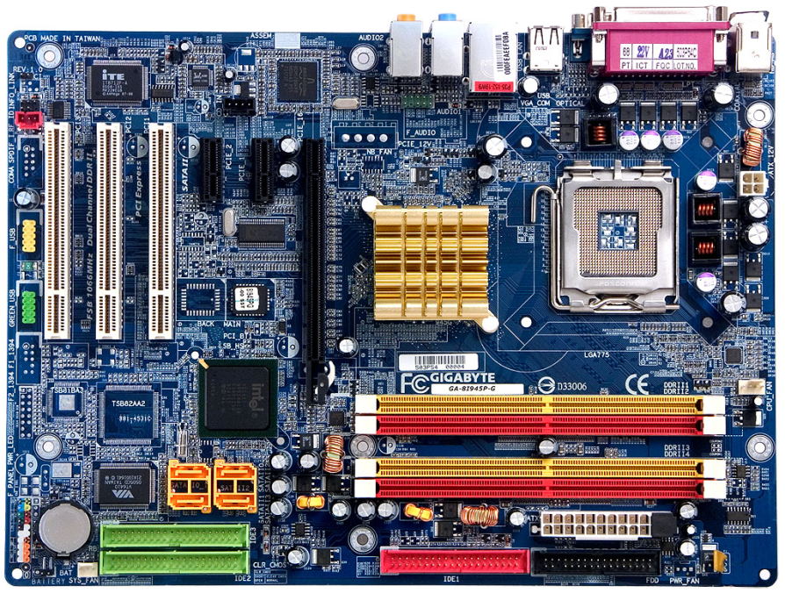

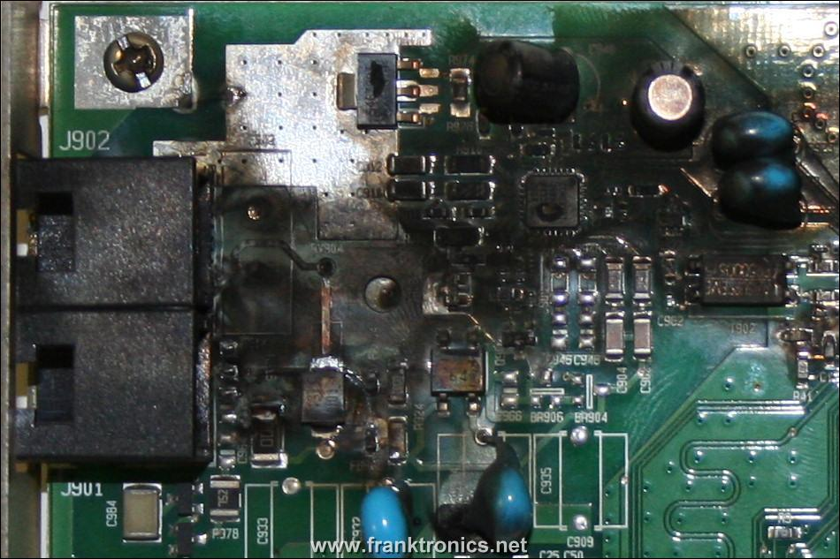

***Level 4 setting (10 sub levels)***

Mainframes/server banks: multiple mainframe/server towers in a white/sterilized room.

* Unique challenges: Multi-tiers, introduction to levels that are raised and different heights.
* Perspective: isometric going down-up/S to N

*When each sublevel is beaten a bank of servers will become blown out with pieces hanging out*

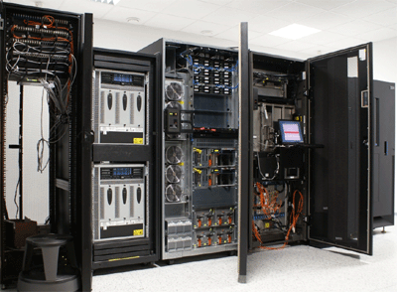

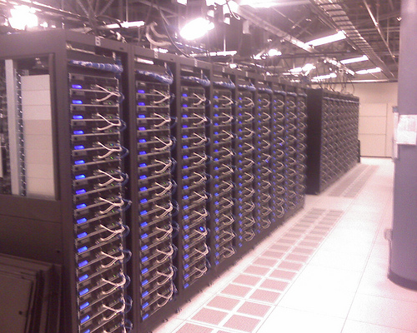

***Level 5 setting (10 sub levels)***

Information Super Highway: World map of the internet. Very high tech/tron looking.

* Unique Challenges: Environment shift and change the longer the player take to win the level.
* Perspective: Changes with each sublevel using all the previous perspectives.

*As the player beats sub levels the “highway lines” will change to the players color (to be selected at beginning of the game).*

 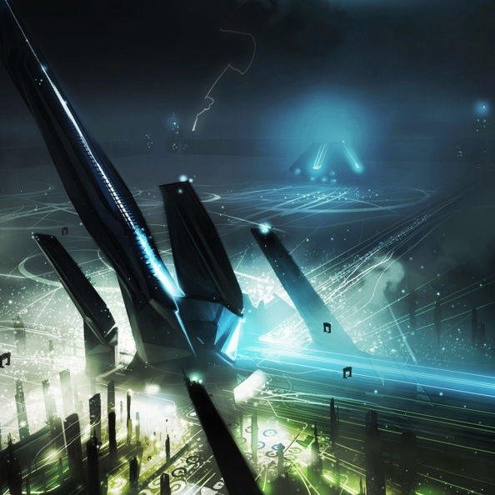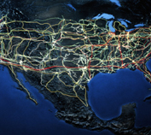

**Challenges**: Non level specific challenges. Used for breaking up game play to keep it from becoming stale/plan/repetitive.

***Budget challenge:*** Complete a set number of levels with limited resources (every level)

***Unit challenge:*** Complete a set number of levels with a limited number of units (every level)

***Boss challenge:*** Defeat a ridiculously strong enemy that is not in the main game (level 2-5)

***Infinite resource:*** Player has unlimited resources. “bonus” challenge end of level reward.

***Software update:*** At random point through the level all defense units will get significantly stronger and have a meaner/menacing looking graphic through the duration. Only last for a set amount of time.

***Hardware update:*** At random points throughout the level new hardware pieces will “fall” onto the playing field blocking off sections of the field from use. Old pieces will be removed opening new areas of play.